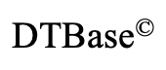**Design & Technology**

**Strategies, techniques and approaches to explore, create and evaluate design ideas**

**Materials required for questions**

* Pencil
* Rubber
* Calculator

**Instructions**

* Use black ink or ball-point pen
* Try answer all questions
* Use the space provided to answer questions
* Calculators can be used if necessary
* For the multiple choice questions, circle your answer

**Advice**

* Marks for each question are in brackets
* Read each question fully
* Try to answer every question
* Don’t spend too much time on one question

**Good luck!**

**Q1.** What is iterative design

**A** A product is never change throughout

the design process

**B** A product is continually analysed, tested

and revisited throughout the design

process

**C** A product is developed once throughout

the design process

**Q2.** What is an advantage of user-centred design?

**A** The user is put at the centre of design

**B** The user is consulted at the end of the

Design

**C** The user is not consulted during the

Design process

**Q3.** Which of these is not an advantage of collaboration when designing

**A** it is an excellent way of gaining feedback

**B** it is a way to take ideas from others

**C** It can help overcomes design fixation

**Q4.** What is ‘Right to repair’?

**A** Law for manufacturers to make their

Products more reliable

**B** Law to make spare parts for expensive

**C** Law to protect you from policies that

Make it difficult/expensive to repair

Products on your own

**Q5.** Which box one of the following is a feature of a product designed for maintenance?

**A** Biodegradable materials

**B** Planned obsolescence

**C** Repairable components

**Q6.** The application of user centred can lead to innovative products being created. Explain the concept of user centred design **(4 marks)**

**Q7.** The image below shows a representation of the circular economy.

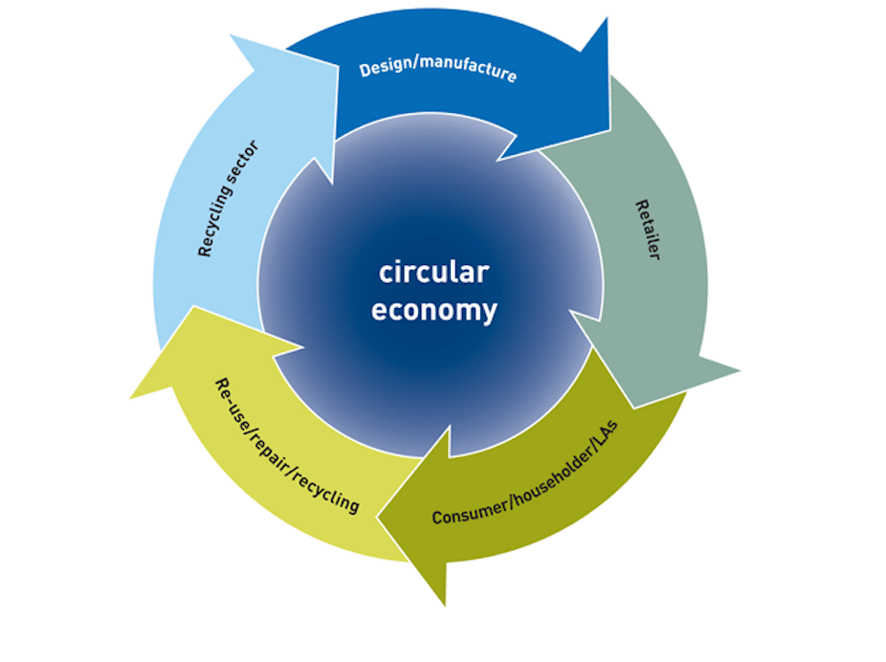

Evaluate the use of the circular economy with reference to suppliers and consumers **(9 marks)**

**Q8a.** The image below shows a picture of a multi-purpose chair that can be used from birth to four years of age.

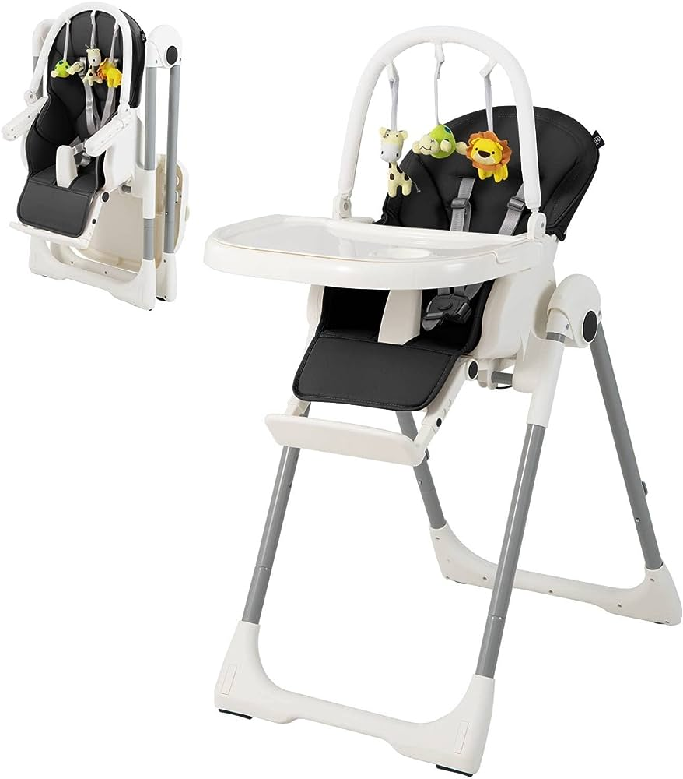

Key design features of the multi-purpose chair include:

* Folding frame with four lockable wheels
* Removable tray and removable activity centre
* Padded reducer to suit different ages / sizes of children
* 8 adjustable height positions
* Adjustable footrest positions
* Reversible padded seating
* Security harness.

Discuss how user centred design may have been used to ensure that the multi-purpose chair is fit-for-purpose for the target market group **(9 marks)**

**Q8b.** Explain three considerations the designer could consider when designing the multi-purpose chair to reduce its lifetime impact on the environment **(9 marks)**

1.

2.

3.

**Answers**

**Q1. B  
Q2. A  
Q3. A  
Q4. C**

**Q5. C**

**Q6.**

* Designers recognize that they do not fully understand how users will instinctively interact with a product (1) so observing consumers use a design is essential. (1)
* It is a reiterative process (1) to achieve the optimum outcome. (1)
* The design is adapted to suit the user (1) rather than the user adapting to suit the design. (1)

**Q7.**

Candidates might refer to the following in their responses:

* Design out/Minimisation of waste, and energy leakage
* Decoupling economic activity from the consumption of finite resources
* Keeps products/materials in use
* A shift from fossil fuels to renewable energies
* Emphasises ‘cradle to cradle’ approach
* Slowing, closing and narrowing material and energy loops
* Contrast to a linear economy which is a ‘take, make, dispose’ model of production
* Optimisation of systems
* Circular framework
* Approach taken to deal with the end of the cheap oil and fossil fuels era
* Transition to a low carbon economy
* Prioritisation of regenerative resources
* Use waste as a resource
* Designing for a lifetime and extended future use
* Preserving and extending what is already made
* Collaboration to create joint value
* Incorporation of digital technologies to track and optimise resource use
* Circular business models

Expansion that can be used to justify judgments relating to positive or negative points:

* Company image and sales
* Consumers need to support and ‘buy-in’ to the circular economy as they can ‘break the chain
* Classic less fashion approach to products to maintain appeal (slow fashion)
* Costs associated with circular economy implementation and alternative energy
* Sustainability benefits and ‘green credentials’
* Consumer support feeling that they are ‘doing their bit for the environment’
* Increase in recycling, associated costs and benefits
* Requirement for recycling infrastructure
* Negative pressure from oil companies and oil producing countries
* Positive support from governments and environmental pressure groups • Investment in waste recovery systems
* Increased use of repair and upgrade programmes including buyback programmes and supporting logistics
* Prices reflecting real cost

**Q8a.**

Candidates might refer to the following in their responses:

* Focus on users and their needs
* Framework process
* Two users – the baby and the adult
* Anthropometrics and ergonomics of both users
* Use of investigative methods
* Use of generative methods
* Iterative process
* User feedback throughout
* Understanding the context of use
* Specifying user requirements
* Production of design solutions
* Evaluation/testing against requirements
* Use of consumer panels
* Real life prototype testing
* More likely to meet expectations and requirements
* Helps designers understand the diversity of cultures
* Key design features of the chair and how USD may have influenced these features.

**Q8b.**

* Consideration of materials selection (1) by use of green/sustainable materials that will reduce the use of finite resources (1) and use of recycled / recyclable materials. (1)
* Consideration of manufacturing methods (1) designing for processes that minimise energy use (1) and achieve optimum use of materials / minimise waste. (1)
* Consideration of distribution methods / packaging shape and size (1) by efficient use of vehicles (1) minimising journey length / use of renewable energy / alternative fuelled vehicles. (1)
* Consideration of how the product is used (1) by designing for energy efficiency (1) and designing for repair rather than replacement. (1)
* Consideration of ease of repair and maintenance (1) by standardisation / use of modular parts (1) and ease of access to components. (1)
* Consideration of end of product life (1) by designing for disassembly / use of recoverable / recyclable materials (1) non-reusable parts suitable for landfill / biodegradable. (1)